الجمهورية اللبنانية
وزارة التربية والتعليم العالي الامتحانات الرسمية لشهادة الامتياز الفني
المديرية العامة للتعليم المهني والتقني لدورة عام 2010 الثانية
===============
الاختصاص والرمز : المعلوماتية الادارية (24004) –الانظمة والشبكات (24101)
المادة : التطوير التطبيقي بالانترنت – البرمجة بلغة الانترنت المعدل: (8-6)
المستندات المسموح بها : لا شيء المدة : ساعة ونصف

N.B: All the "HTML" files are in the folder: \web
All the "AUDIO" and "VIDEO" files are in the folder: \web\sounds
All the "IMAGES" files are in the folder: \web\photo
All others files are in the folder: \misc

I- Write the appropriate tags to obtain as a result the following page " main.html" respecting the following conditions:  (4 pts)  - The title has the biggest possible size.  - The title color is red  - The page background color is blue.  - The car image name is « picture1.jpg »  - The image «Enter» is «picture2.jpg».A click on this image displays the HTML page "page1.html".  - The name of the Audio file is « Speaker.mp3 ». A click on this file will launch the audio file infinitely.  - The keywords for the search engines are: car, rent, online. | 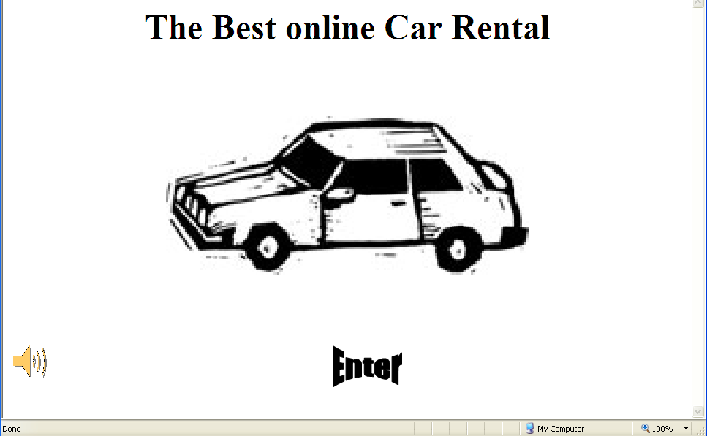
II- Write the appropriate tags to obtain as a result the following page "page1.html" respecting the following conditions:  (4 pts)  - The background color of the table is a mixture of blue, green and red.  - The border color of the table is green and the thickness is 3 pixels.  - The distance between the text and the table border is of 1 pixel.  - The link «Download price list» download the file «prices.xls».  - The name of the image «Return to main Page» is « banner2.jpg ». A click on this image points toward the html page «index.html».  - The truck image name is «truck». It's an animated image; therefore it's up to you to choose the suitable extension.  - Bullets and numbering are lists | 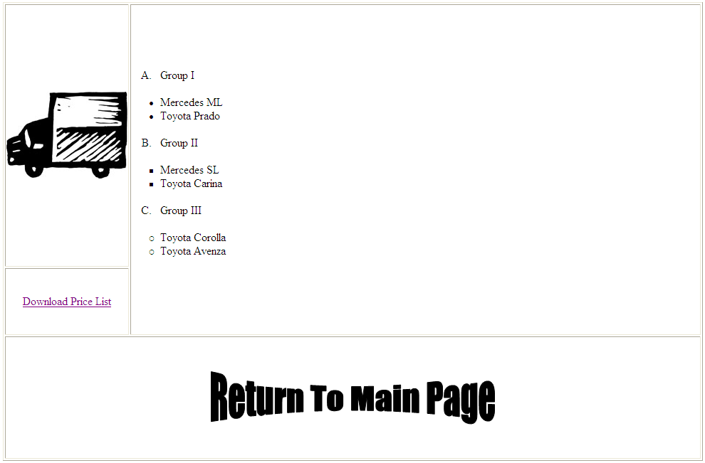

الاختصاص والرمز : المعلوماتية الادارية (24004) –الانظمة والشبكات (24101)
المادة : التطوير التطبيقي بالانترنت – البرمجة بلغة الانترنت المعدل: (8-6)
المستندات المسموح بها : لا شيء المدة : ساعة ونصف

 | III- Write the appropriate tags to obtain as a result the following page «rent.html » respecting the following conditions:  (4 pts)  - Full Name: Entry field of 25 characters.  - Phone Number: Entry field of 25 characters. Visible characters are 10.  - Address: Entry field of 50 characters.  - We can choose multiple groups at the same time.  - A Submit Query button send the values to the server« www.mysite.com » by using a script called "submit.pl"  - A Reset button to restore the default values. | 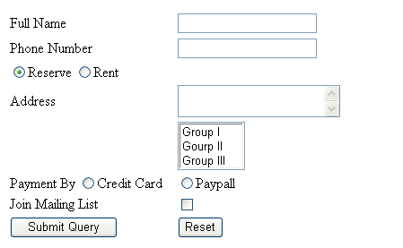

IV- Write the appropriate tags to obtain as a result the following page " indexonline.html" respecting the following conditions  (8 pts)  - This page is divided into 3 frames A, B and C.  - The frame "A" contains the scrolling message « Vrooommm » and the pictures  « car1.jpg ». The moving is from left to right infinitely.  - The frame "B" holds multiple links.  - The links « Group I »,« Group II » and « Group III » display the page « page1.html » in frame C. Each link points to its corresponding part « Group I »,« Group II » and « Group III ».  - The link « Contact US » Will send an email  to the address « Rentoo@hotmail.com »  - The Link « Rent Page » displays the page  «rent.html » in the frame "A".  - The frame "C" displays by default the page «main.html».  - Create all needed and not exiting pages, and add all needed tags to the existing pages. | Frame A:  Width: 85 %  Height: 30%  Frame B:  Width: 15 %  Height: 100%  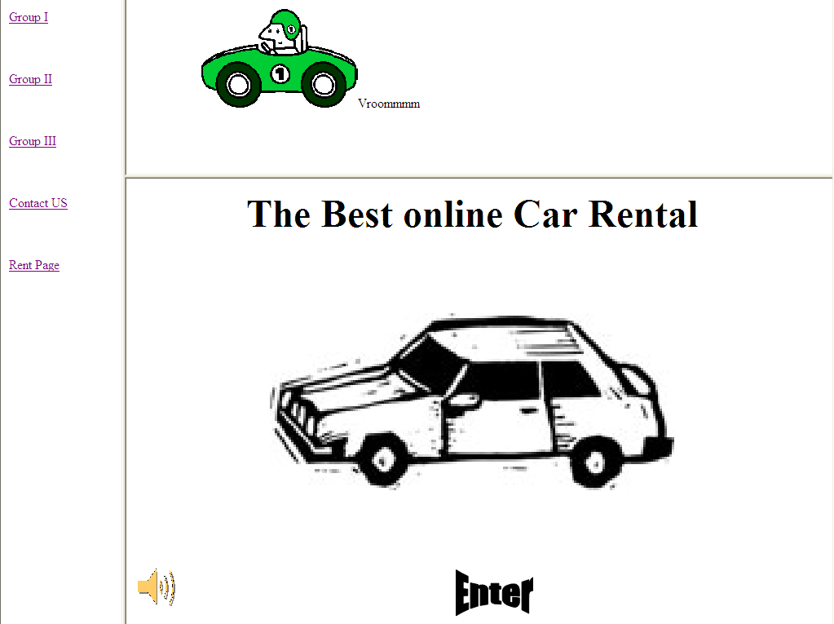
Frame C:
Width: 85 %
Height: 70%

